# VISVESVARAYA TECHNOLOGICAL UNIVERSITY

**“Jnana Sangama”, Belagavi-590 018, Karnataka**

**Project Report on**

“AIRLINES SEAT RESERVATION SYSTEM”

**Submitted in partial fulfillment of the requirements for the award of the degree of Bachelor of Engineering**

**in**

**Computer Science & Engineering**

**Submitted by**

**USN Name**

**1BI20CS011 Aditya Kulkarni**

**1BI20CS060 Divyansh Nama**

**1BI20CS065 Gaurav Saraiwala**

**1BI20CS077 Himank Mishra**

**1BI20CS117 Nishit Khamesra**

**1BI20CS** **153 Satyam Kumar**

Under the Guidance of

**Sushma H.R.**

Assistant Professor Department of CS&E, BIT Bengaluru-560004



**DEPARTMENT OF COMPUTER SCIENCE & ENGINEERING**

# BANGALORE INSTITUTE OF TECHNOLOGY

K.R.Road, V.V.Pura, Bengaluru-560 004

## 2020-21

**VISVESVARAYA TECHNOLOGICAL UNIVERSITY**

**“Jnana Sangama”,** Belagavi-590 018, Karnataka

## BANGALORE INSTITUTE OF TECHNOLOGY

Bengaluru-560 004



**DEPARTMENT OF COMPUTER SCIENCE & ENGINEERING**

***Certificate***

This is to certify that the implementation of **C PROGRAMMING FOR PROBLEM SOLVING MINI PROJECT** (18CPS23) entitled “**AIRLINES SEAT RESERVATION SYSTEM**” has been successfully completed by

**Name USN**

**Aditya Kulkarni 1BI20CS011**

**Divyansh Nama 1BI20CS060**

**Gaurav Saraiwala 1BI20CS065**

**Himank Mishra 1BI20CS077**

**Nishit Khamesra 1BI20CS117**

**Satyam Kumar 1BI20CS** **153**

of II semester B.E. for the partial fulfillment of the requirements for the Bachelor's degree in Computer Science & Engineering of the Visvesvaraya Technological University during the academic year 2020-2021.

**Sushma H.R.**

Assistant Professor

Department of CS&E, BIT

|  |  |  |
| --- | --- | --- |
|  |  |  |
|  |  |  |

**Abstract**

* The AIRLINES is a simple project which is designed in **C language**.
* The coding of this project is done in such a way that the user feels very interesting while booking a flight ticket.
* This project is coded in such a way that it's very **user-friendly**. This project is developed in the IDE called as **Visual Studio Code and Fedora** with the help of **GCC compiler**.
* When you run the application will be asked to enter certain details to book your flights.

**Acknowledgement**

We take this opportunity to acknowledge all the people who have helped us wholeheartedly in every stage of this project. We would like to express our sincere gratitude to Mrs. Sushma and our honorable principal Dr Aswath M.U. of Bangalore Institute of Technology for their valuable guidance and support in completing my project in C programming on **Airlines Seat Reservation System.**

Your valuable guidance and suggestions helped us in various phases of the completion of this project.

Finally, as a team, we would also like to appreciate each one of us for their support and coordination in the completion of this project. We hope we will achieve more in our future endeavors.

**Index**

**Chapter 1: Introduction**

**Chapter 2: Problem Statement and Objective**

**Chapter 3: System Requirements**

**Chapter 4: Flowchart with explanation**

**Chapter 5: Design**

5.1: Algorithm Design

**Chapter 6: Implementation**

**Chapter 7: Testing and Results**

**Chapter 8: Applications**

**Chapter 9: Conclusion and Future work**

**Chapter 10: References**

**CHAPTER-1**

**INTRODUCTION**

**1. 1 About Airlines Seat Reservation System :**

**Airline reservation systems** (**ARS**) are systems that allow an airline to sell their inventory (seats). It contains information on schedules and fares and contains a database of reservations (or passenger name records) and of tickets issued (if applicable). ARSs are part of [passenger service systems](https://en.wikipedia.org/wiki/Passenger_service_system) (PSS), which are applications supporting the direct contact with the passenger.

ARS eventually evolved into the [computer reservations system](https://en.wikipedia.org/wiki/Computer_reservations_system) (CRS). A computer reservation system is used for the reservations of a particular airline and interfaces withThrough this system the customer can book the flight tickets hassle free by providing their details. Customer can book seats they want, meals and further any add ons (if any).

The boarding pass will be issued once the payment is completed. a [global distribution system](https://en.wikipedia.org/wiki/Global_distribution_system) (GDS) which supports travel agencies and other distribution channels in making reservations for most major airlines in a single system.

The Objective of this project is to help and assist the airline people to maintain the database of all the reservations taking place in the Airlines.

**CHAPTER-2**

**PROBLEM STATEMENT AND OBJECTIVE**

**2.1 Problem Statement :**

Every airline company is charged with the responsibility of ensuring to give safe and comfortable service for its customers. To ensure this quality of service, the companies which work on this business should reach to their customers and give quality service to compete in the market.

This includes easy and user-friendly ticket reservation system. In the manual system, the daily reservation list of all the passengers is generated and sent. Thus very often they are not able to put up the reservation list on time, owing to the inefficiencies in the manual system. Currently the manual system handles all the requests for changes in the reservation.

Reservation opens a few days before the scheduled departure date. Based in the availability of the seats the tickers are issued. Each ticket whether wait-listed or confirmed has a unique identification number. This number is generated in serial order. The reservation clerk records the amount of fare to be paid for the ticket in Cash Collection Register.

**2.2 Objectives :**

The Objective of this project is to help and assist the airline people to maintain the database of all the reservations taking place in the Airlines.

**CHAPTER-3**

**SYSTEM REQUIREMENTS**

**3.1 System requirements:**

**3.1.1 The minimum requirements are: -**

3.1.1.1 Intel Core i5 or i7 processor

3.1.1.2 Full HD resolution, ideally 1920×1080

3.1.1.3 8GB of RAM

**3.1.2 IDE used: -**

VS CODE

Visual Studio Code is a code editor made by Microsoft for Windows, Linux and macOS. Features include support for debugging, syntax highlighting, intelligent code completion, snippets, code refactoring, and embedded Git.

Also we used Fedora IDE.

**3.1.3 Compiler used**: -

MinGW is a compiler system based on the GNU GCC and Binutils projects that compiles and links code to be run on Win32 (Windows) systems. It provides C, C++ and Fortran compilers plus other related tools. 'MinGW' refers to the "Minimalist GNU for Windows" project.

**CHAPTER-4**

**FLOWCHART WITH EXPLANATION**

**4.1 Flow chart:**

Read source, destination, passenger(n)

Price=price

=1500

F

T

Is seat type==2

?

Read seat number

F

T

Is seat type==1

?

Read seat type

i 0

i++

i<n

Read flight code

Read date

F

Is seat==

Window seat?

Is seat==

Middle

?

F

T

Price 3000

Price 2500

Price 2500

Read name, mobile no, age, gender

F

T

Is food==

selected

Price=price

F

T

Is food choice==veg?

Price=price+350

Price=price+300

Print name, mobile no, age, gender, food choice, seat number.

Pay

Read card holder name, acc no, exp date

Read bank name,

Net banking id

F

T

Is payment

==net

Banking?

Read UPI id

F

T

is payment

==UPI

Read payment option

Read price

**CHAPTER-5**

**DESIGN**

**5.1 Algorithm Design :**

Step 1: Start

Step 2: [Input the source city and destination city]

read num1 & num2

Step 3: [Input the number of tickets]

read n

Step 4: [Input the date of travel in specified format]

read day,month,date

Step 5: [display of Flights Details along with the time]

for I <- 0 to 4

print details of flights

Step 6: [Choose the airline you want to board]

print "select airlines"

print details of selected flights

Step 7: [Display of all the seats]

for k<-0 to 1

print "NORMAL SEATS"

for j<-(0+5*k) to (2+5*k)

print seat numbers with spacing

end for

print "EXTRA LEG SPACE SEATS"

for j<-(3+5*k) to (4+5*k)

print seat numbers with spacing

end for

end for

Step 8: [Display the pricing of the seats]

print the pricing of all types of seats

Step 9: [Show the type of selected seat]

print details of type seat selected for respective passenger

Step 10: [Checking validity of entered a seat number]

if invalid

tell user invalid seat number and ask to input again

Step 11: [Checking if entered seat is vacant or not]

if vacant

then allot seat

else if not vacant

ask to re-enter

end if

Step 12: [Display selected seat details for respective passenger]

print "Window seat, Middle Seat or Inner Seat" based upon selection

Step 13: [Input the Required Passengers Details]

for if<-0 to

read "name[i],phno[i],gen[i],age[i]"

Step 14: [Input the food choice]

for i<-0 to

if (food_required[i]==1)

read "food_choice[i]"

if (food_choice[i]=1)

food_price<- 250

else

food_price<- 350

else

food_price<-0

end if

end for

Step 15: [Doing Payment]

Print"choose from following payment options"

1=UPI Payment

2=Net Banking

3=Debit And Credit Card

switch(choice)

case'1' : read details of UPI id and do payment

case'2' : read details of bank,netbanking ID and do payment

case'3' : read card details,CVV and do payment

Step 16: [Confirm your payment]

Print"press 1 to confirm payment else press any other key"

read x

if x==1

make payment

else

goto step 19

end if

Step 17: [Issue and Printing of Boarding Pass]

Print"Airlines name"

Print"name,phno,gen,age"

Print"source_city,dest_city"

Print"finalprice"

(printing all within a box for each passenger)

Step 18: [Display the Greetings]

Print"BOOKING SUCCESFUL ,Wishing you a safe and happy journey ,Thank you for choosing us,looking forward to serve you again soon"

Step 19 : Stop

**CHAPTER-6**

**IMPLEMENTATION**

**6.1 Ladder If-Else Statements :**

In C/C++ if-else-if ladder helps user decide among multiple options.

We have made use of if-else-is-if ladder in showing details of seat (including seat number, overall price etc) at the end of seat selection for each passenger.

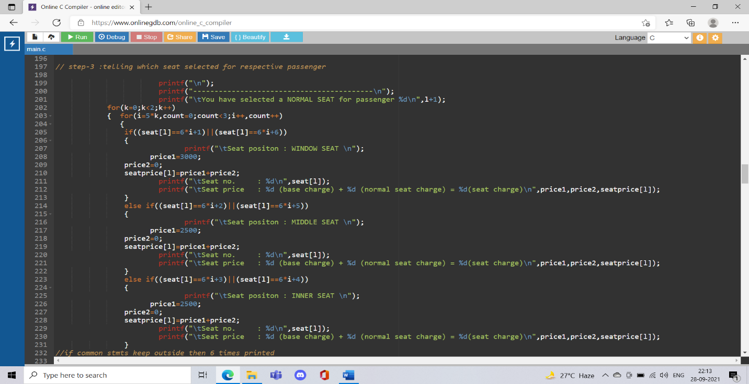

If-else if-else loop used in seat selection part to display selected seat details

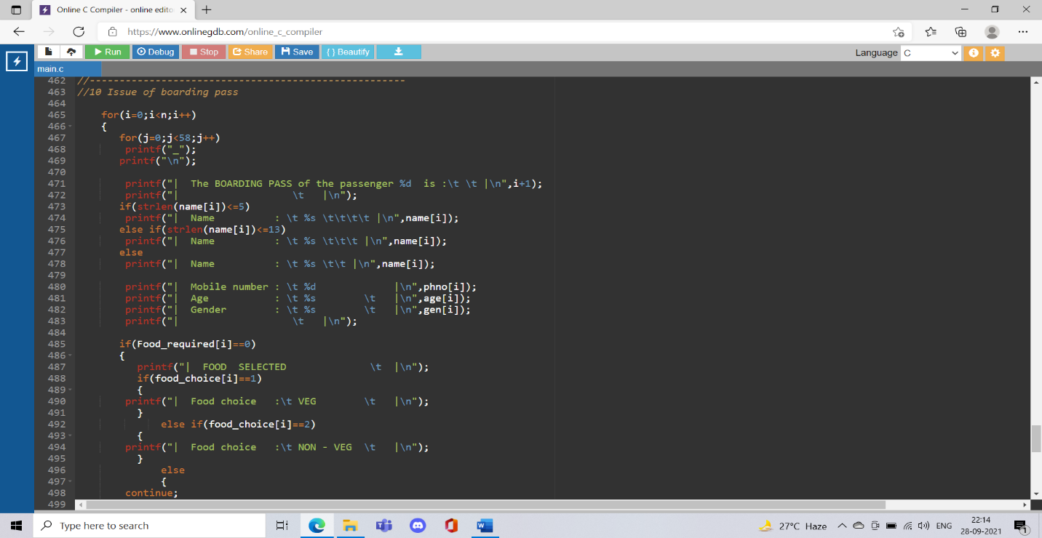

If-else if-else part used for printing boarding pass.

**6.2 Switch case :**

Switch case also helps user in choosing among multiple options.

Here we use cases as the name suggests, and the case label being of character or integer type.

We have used switch case for selecting the type of seat required (normal or extra leg space seats)

We have also used switch case in payment part of the code.

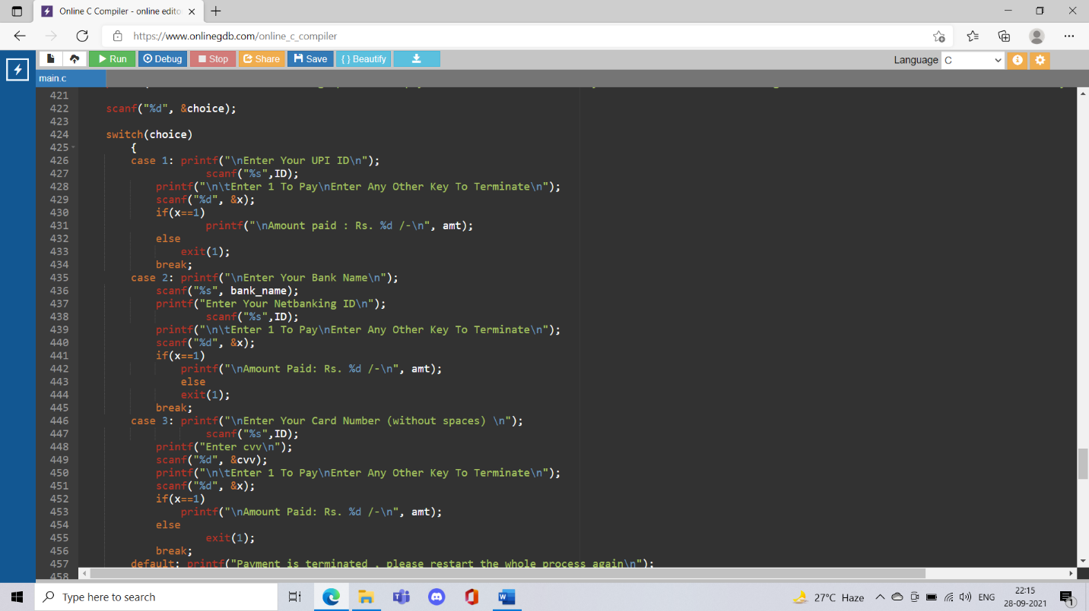

Switchcase used in payments part

**6.1 For Loop :**

A for loop is a repetition control structure which allows us to write a loop that is executed a specific number of times. The loop enables us to perform n number of steps together in one line.

We have extensively used for loops at many instances including display of flight details, seat

layout, selection of seats, reading passenger details, selection of food choice, printing boarding passes etc.

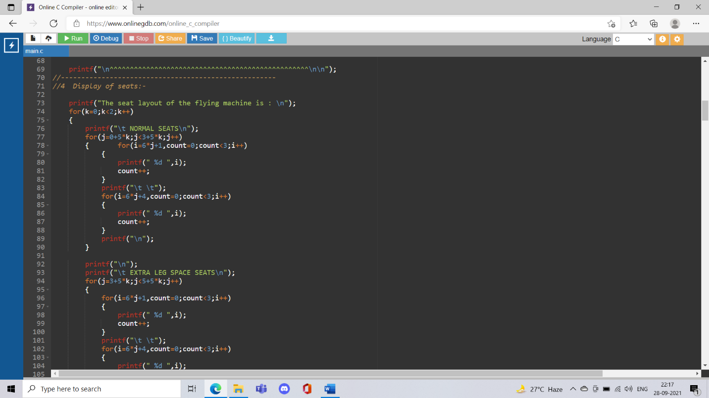

For loop used for showing seat layout of Normal Seats

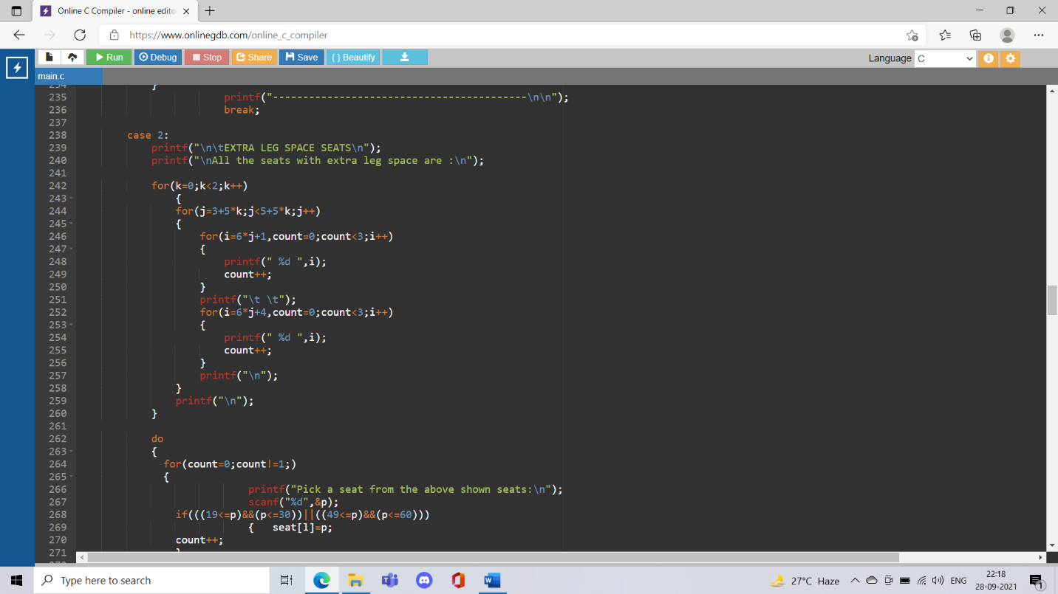

For loop used for showing seat layout of Extra Large Seats

**CHAPTER-7**

**TESTING AND RESULTS**

**7.1 Testing :**

Here we have provided pictures of code running in actual time.

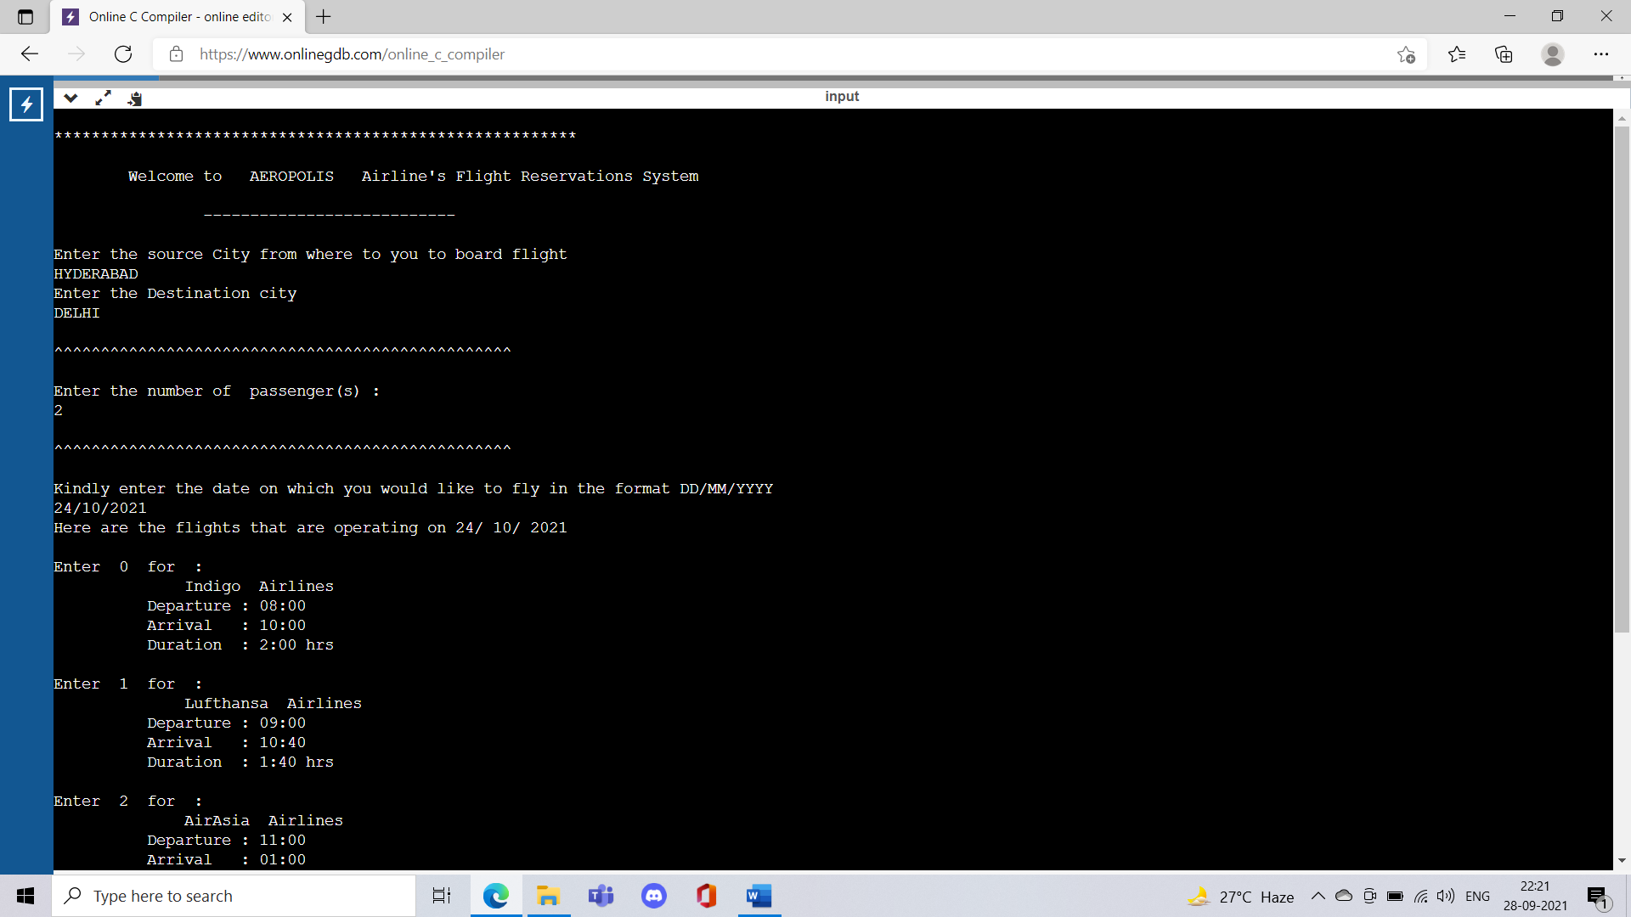

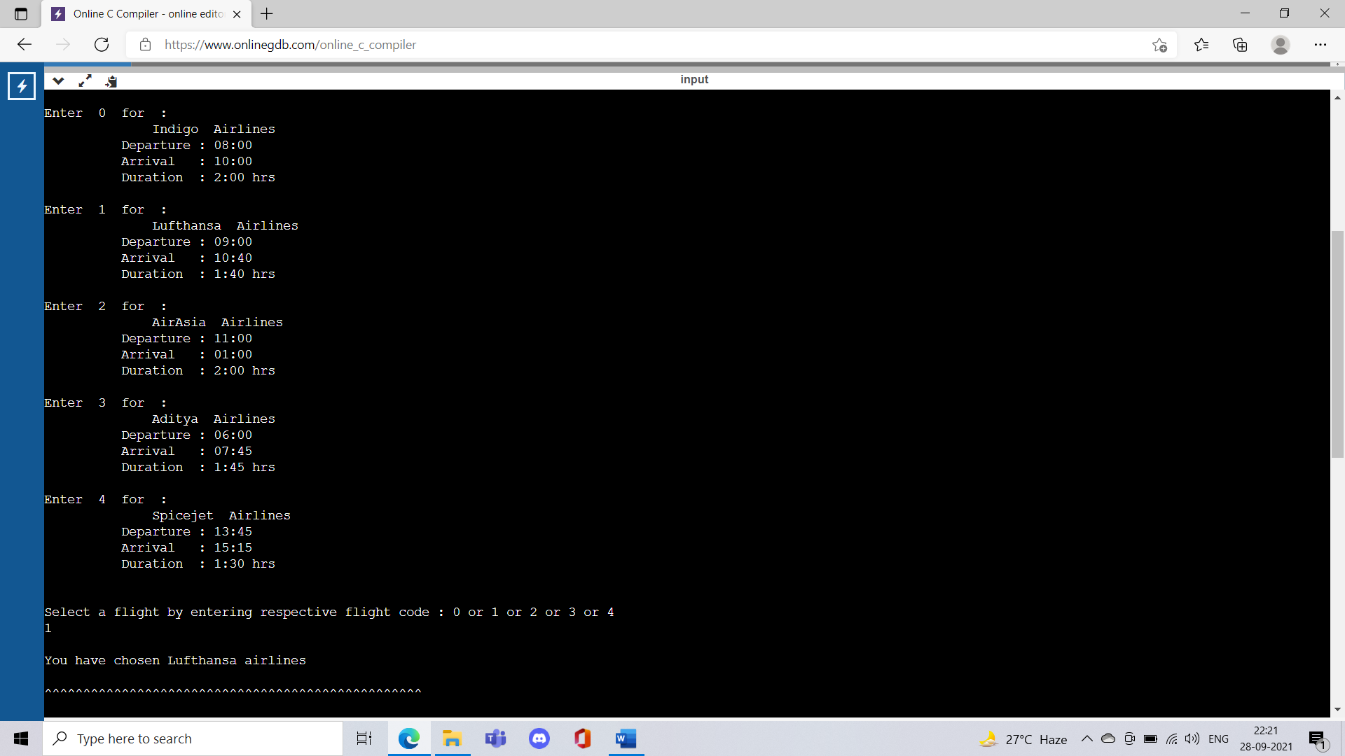

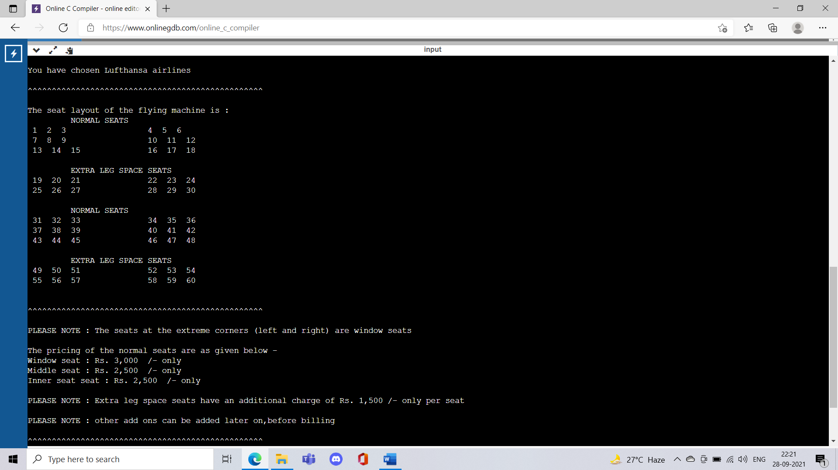

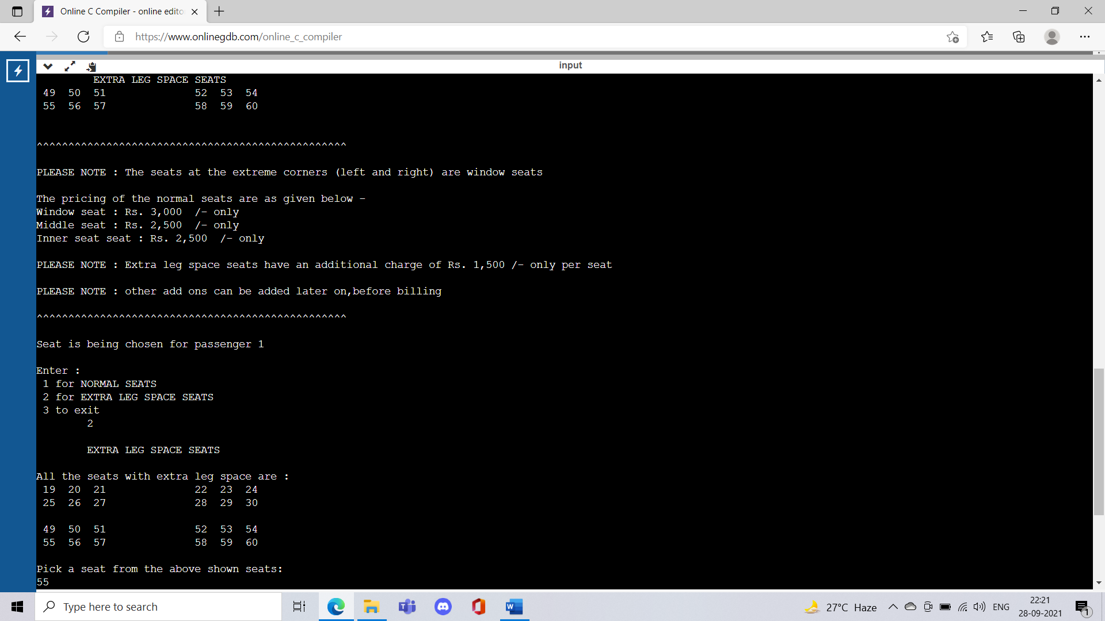

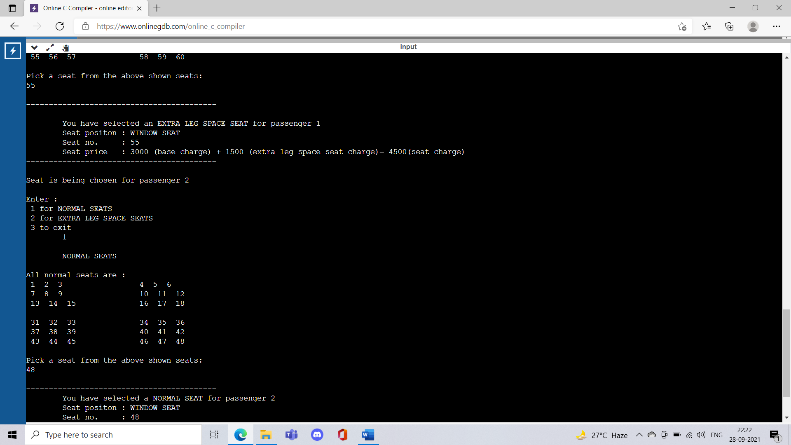

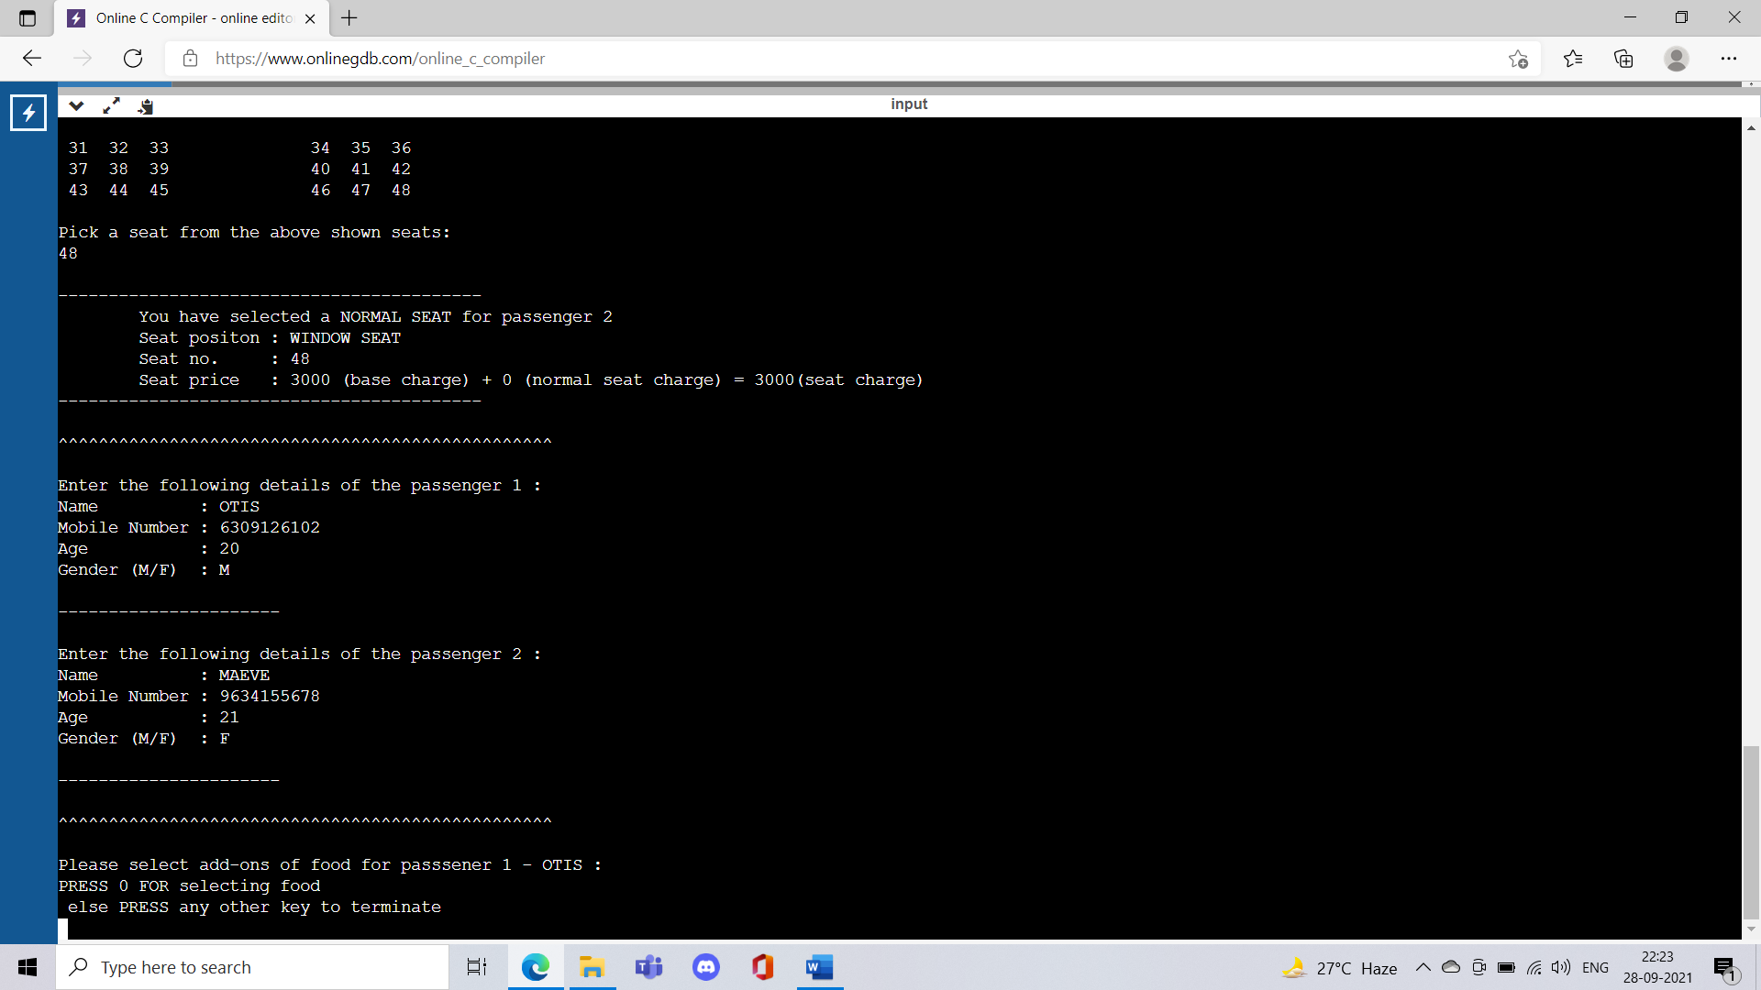

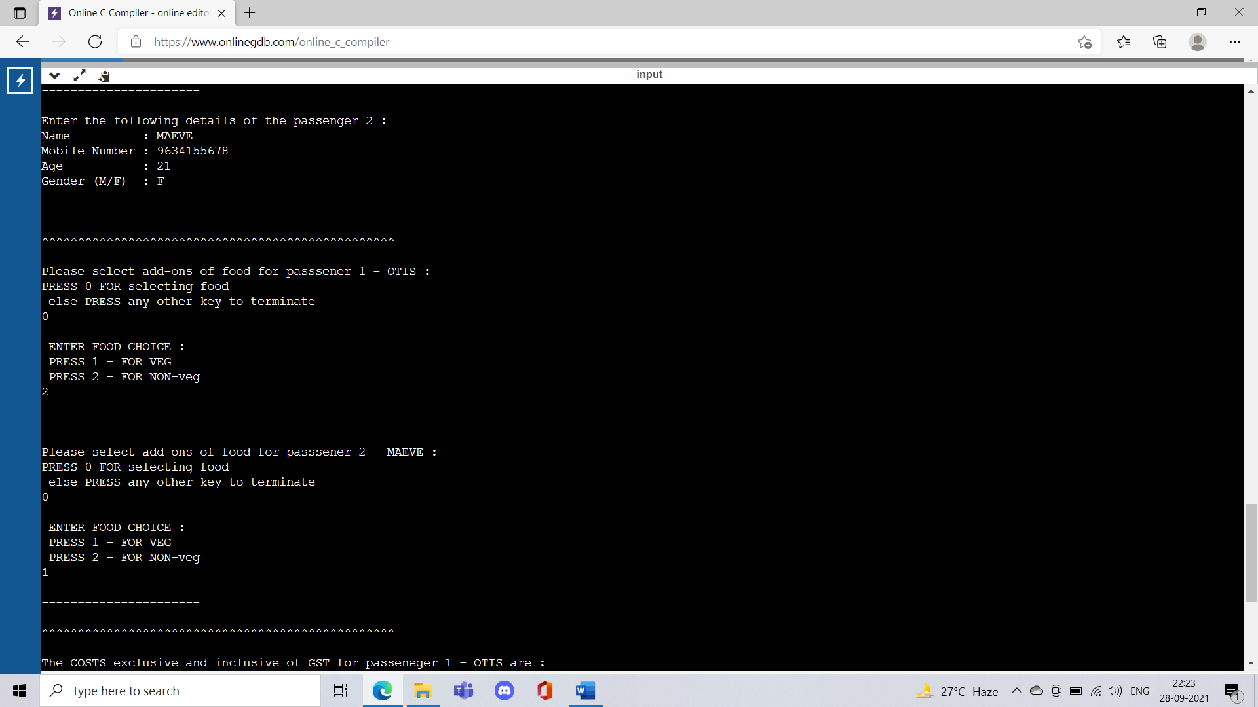

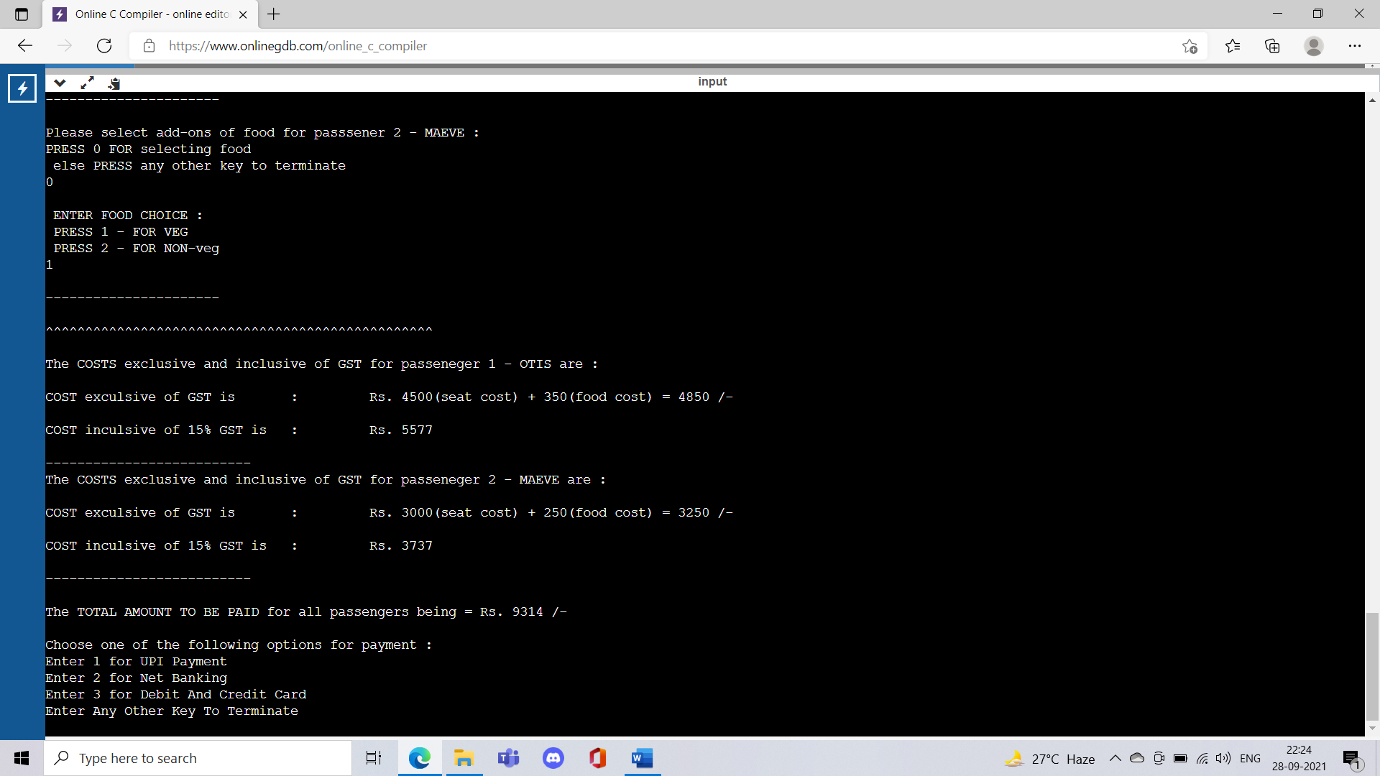

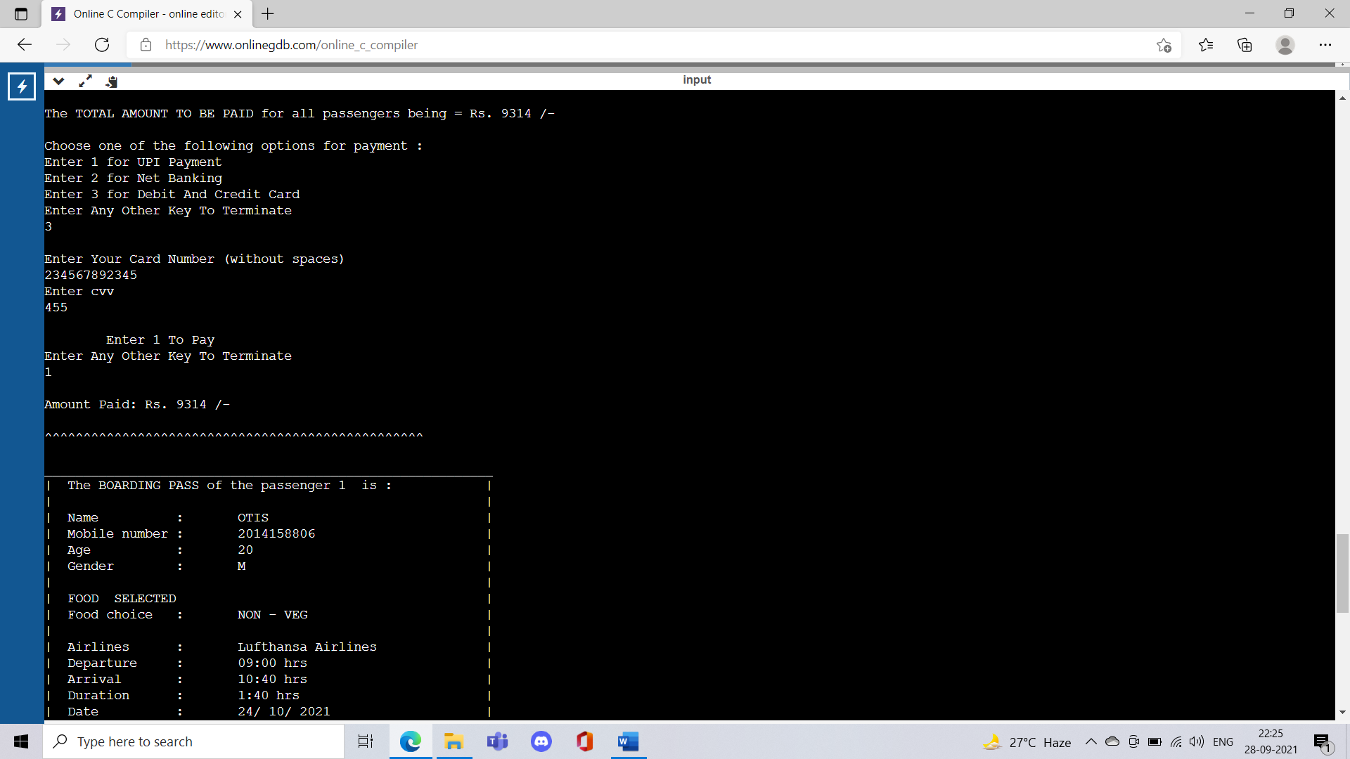

**7.2 Results :**

The following pictures show the final output i.e. the boarding pass printed at the end followed by greeting from the airlines.

P.T.O. for the pictures

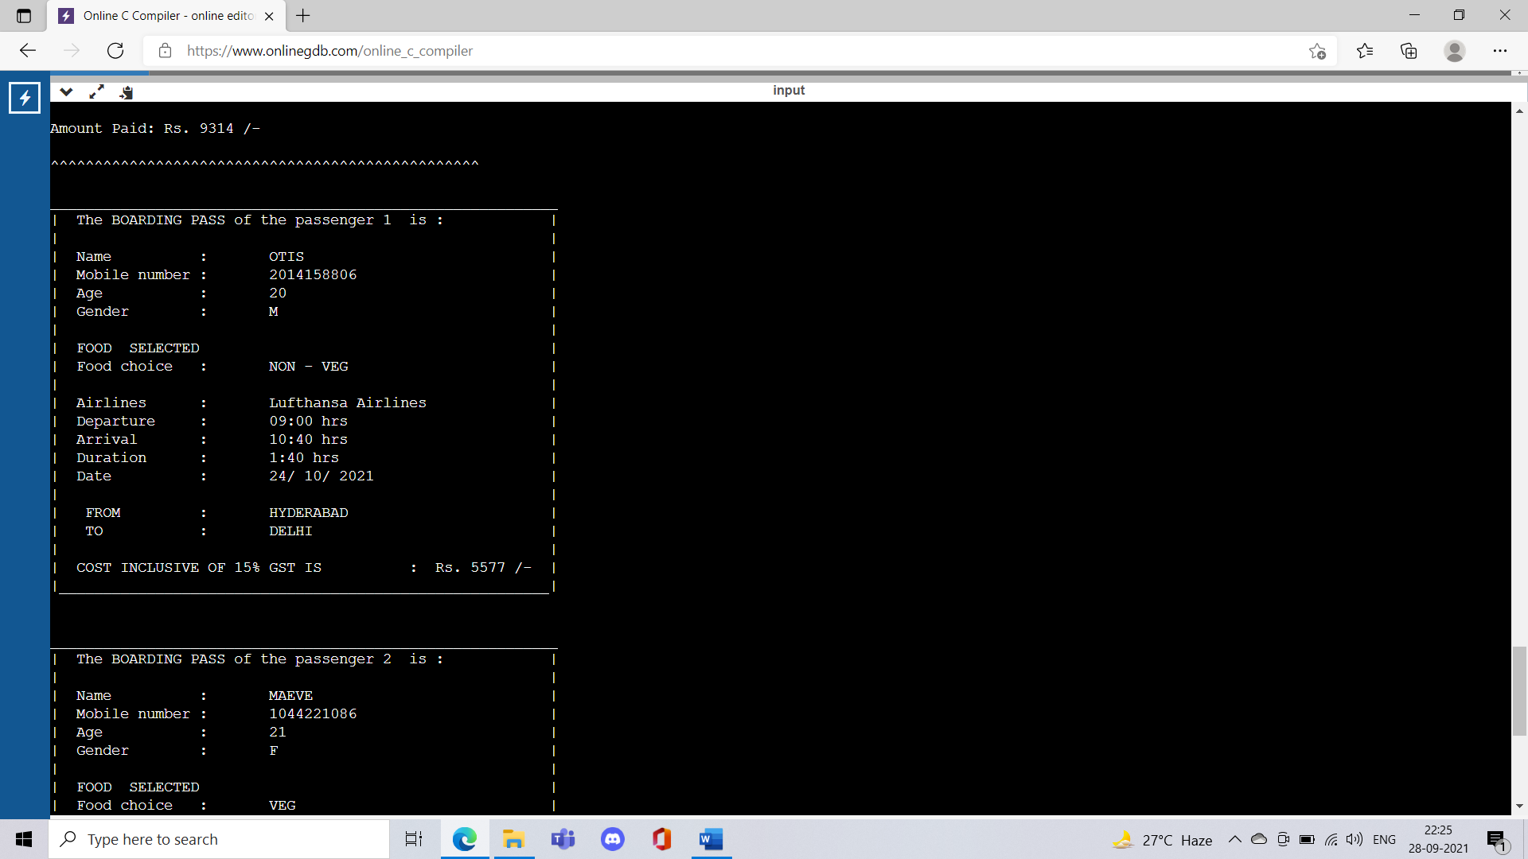

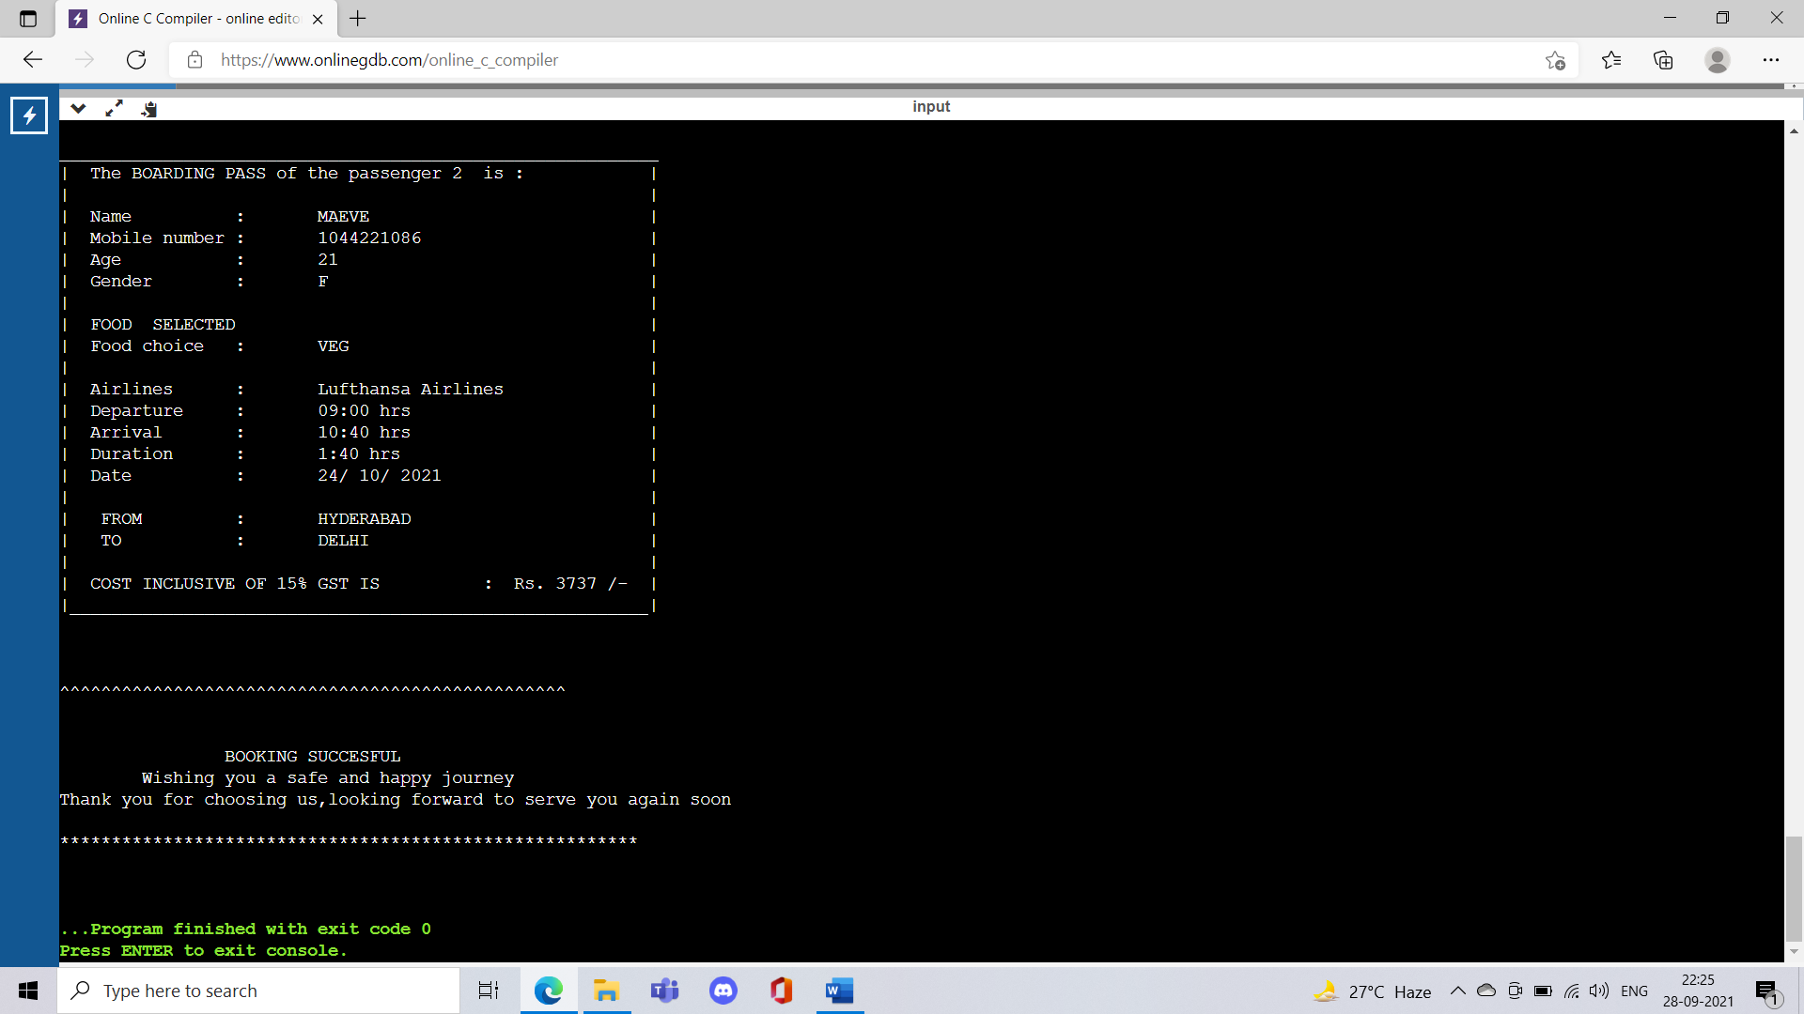

**CHAPTER-8**

**APPLICATIONS**

**8.1 Applications :**

With the help of our code, it becomes easy and hassle free to book online tickets from anywhere.

We have almost covered every topic of basic coding in making this project. We further envision to make this code much better and more friendly for user. Our code basically makes one to think what are the back actions of the keywords that one press for the booking of tickets. It further inspires and encourages an individual about how an airlines company works and earns.

**CHAPTER-9**

**CONCLUSION AND FUTURE WORK**

**9.1 Conclusion and Future Work :**

**9.1.1 CONCLUSION**

The code we made is a low level code which will help the airlines in providing a user friendly and interactive interface for reservation of seats.

**9.1.2 FUTURE WORK**

Moreover, in this project we can add a piece of code which helps in displaying only the seats available (and not showing the occupied ones) while selecting seat for each passenger.

Also we can add another piece of code which will help in adding feature of ticket cancellation facility.

**CHAPTER-10**

**REFERENCES**

**10.1 References :**

**10.1.1 geeksforgeeks.org**

**10.1.2 stackoverflow.com**

**10.1.3 cppreference.com**

**10.1.4** [**www.tutorialspoint.com**](http://www.tutorialspoint.com)